Question 8 (6 marks)

A particle moves in space with position vector cm, where is the time in seconds since its motion began.

(a) Determine the distance of the particle from its initial position after $\begin{matrix}π \\ \overline{3}\end{matrix}$ seconds. (3 marks)

(b) Show that the particle is moving with a constant speed. (3 marks)

Question 8 (6 marks)

A particle moves in space with position vector $\underset{∼}{r}(t)=\left(\begin{matrix}2\cos{(4t)} \\ -3t \\ -2\sin\left(4t\right)\end{matrix}\right)$ cm, where $t$ is the time in seconds since its motion began.

(a) Determine the distance of the particle from its initial position after $\begin{matrix}π \\ \overline{3}\end{matrix}$ seconds. (3 marks)

|  |
| --- |
| Solution |
|  |
| Specific behaviours |
| ✓ position vectors at $t=0$ and required time  ü displacement vector  ü correct distance |

(b) Show that the particle is moving with a constant speed. (3 marks)

|  |
| --- |
| Solution |
| Velocity vector: $$\underset{∼}{v}\left(t\right)=\frac{d}{dt}\left(\underset{∼}{r}\left(t\right)\right) \\ =\left(\begin{matrix}-8\sin{(4t)} \\ -3 \\ -8\cos\left(4t\right)\end{matrix}\right)$$ Speed:  Hence particle is moving with a constant speed. |
| Specific behaviours |
| ü correct velocity vector  ü correct expression for magnitude of vector  ü simplifies magnitude to show constant |

Question 9 (6 marks)

Particles $A$ and $B$ are moving with constant velocities and have initial positions $\left(\begin{matrix}-8 \\ 2 \\ 10\end{matrix}\right)$ m and $\left(\begin{matrix}7 \\ 7 \\ -15\end{matrix}\right)$ m respectively. $2$ seconds later $A$ is at $\left(\begin{matrix}0 \\ -2 \\ 4\end{matrix}\right)$ m.

(a) Determine the velocity of $A$. (1 mark)

The velocity of $B$ is $\left(\begin{matrix}1 \\ -3 \\ 2\end{matrix}\right)$ m/s.

(b) Show that the paths of $A$ and $B$ cross, state the position vector of this point, and explain whether the particles collide. (5 marks)

Question 9 (6 marks)

Particles $A$ and $B$ are moving with constant velocities and have initial positions $\left(\begin{matrix}-8 \\ 2 \\ 10\end{matrix}\right)$ m and $\left(\begin{matrix}7 \\ 7 \\ -15\end{matrix}\right)$ m respectively. $2$ seconds later $A$ is at $\left(\begin{matrix}0 \\ -2 \\ 4\end{matrix}\right)$ m.

(a) Determine the velocity of $A$. (1 mark)

|  |
| --- |
| Solution |
| $$\underset{∼}{v_{A}}=\frac{1}{2}\left(\left(\begin{matrix}0 \\ -2 \\ 4\end{matrix}\right)-\left(\begin{matrix}-8 \\ 2 \\ 10\end{matrix}\right)\right)=\left(\begin{matrix}4 \\ -2 \\ -3\end{matrix}\right)$$ |
| Specific behaviours |
| ✓ correct velocity |

The velocity of $B$ is $\left(\begin{matrix}1 \\ -3 \\ 2\end{matrix}\right)$ m/s.

(b) Show that the paths of $A$ and $B$ cross, state the position vector of this point, and explain whether the particles collide. (5 marks)

|  |
| --- |
| Solution |
| $$\underset{∼}{r_{A}}(t)=\left(\begin{matrix}-8 \\ 2 \\ 10\end{matrix}\right)+t\left(\begin{matrix}4 \\ -2 \\ -3\end{matrix}\right), \underset{∼}{r_{B}}(s)=\left(\begin{matrix}7 \\ 7 \\ -15\end{matrix}\right)+s\left(\begin{matrix}1 \\ -3 \\ 2\end{matrix}\right)$$ For paths to cross we require $\underset{∼}{r_{A}}=\underset{∼}{r_{B}}$. Equating $\underset{∼}{i}$ and $\underset{∼}{j}$ coefficients and solving simultaneously: $$4t-8=s+7, 2-2t=7-3s⇒t=5, s=5$$ Check $\underset{∼}{k}$ coefficients are equal with these values of $t$ and $s$: $$t=5⇒10-3\left(5\right)=-5, s=5⇒-15+2\left(5\right)=-5$$ Because $\underset{∼}{r_{A}}(5)=\underset{∼}{r_{B}}(5)=\left(\begin{matrix}12 \\ -8 \\ -5\end{matrix}\right)$, their paths cross at this point and because both particles reach this point at the same time they collide. |
| Specific behaviours |
| ✓ indicates equations for both paths  ü forms two equations using different time parameters  ü solves equations and checks third coefficient  ü correct position vector  ü explains why paths cross and whether particles collide |

Question 10 (9 marks)

(a) Draw the subset of the complex plane determined by $\left|z+3\right|>|z-3i|$ on the axes below.

(3 marks)

<EFOFEX>
id:fxd{ae2acad5-552d-4117-9965-f12397a8d54b}

FXData:

</EFOFEX>

|  |
| --- |
| Solution |
| See diagram |
| Specific behaviours |
| ✓ indicates points in plane  ü draws perp’ bisector with dotted line  ü shades correct region |

<EFOFEX>
id:fxd{3b95f65c-8585-4808-a8f7-0c5259a934c2}

FXData:

</EFOFEX>

(b) The circular arc in the diagram represents  
the locus of a complex number $z$.  
  
  
Without using $Re(z)$ or $Im(z)$, write  
equations or inequalities in terms of $z$  
for the indicated locus.  
  
  
  
 (3 marks)

|  |
| --- |
| Solution |
| Circle has centre $-1+2i$ and radius . |
| Specific behaviours |
| ✓ indicates correct centre and radius  ü writes inequality for circle  ü writes restriction for $\arg{z}$ |

(c) Describe the subset of the complex plane determined by $\left|z-3\right|+\left|z+3i\right|=3\sqrt{2}$.

(3 marks)

|  |
| --- |
| Solution |
| Distance between $3$ and $-3i$ in complex plane is $3\sqrt{2}$.  Hence $z$ must lie on the line segment between $3$ and $-3i$ inclusive in the complex plane.  Alternatively, when $z=x+iy$ then locus is $y=x-3, 0≤x≤3$. |
| Specific behaviours |
| ✓ indicates distance between points  ü indicates subset is a line segment  ü correct description that includes endpoints |

Question 12 (7 marks)

Relative to an origin $O$ located on level ground, a projectile is launched from $\left(\begin{matrix}0 \\ 7.5\end{matrix}\right)$ m with an initial velocity of m/s. The motion of the projectile is only affected by a constant acceleration of m/s2.

(a) Derive from the acceleration vector an expression for the position vector $\underset{∼}{r}(t)$ of the projectile $t$ s after its launch. (3 marks)

(b) Determine the distance travelled through the air by the projectile from when it is launched until the instant it reaches the ground, correct to the nearest $0.1$ m. (4 marks)

Question 12 (7 marks)

Relative to an origin $O$ located on level ground, a projectile is launched from $\left(\begin{matrix}0 \\ 7.5\end{matrix}\right)$ m with an initial velocity of m/s. The motion of the projectile is only affected by a constant acceleration of m/s2.

(a) Derive from the acceleration vector an expression for the position vector $\underset{∼}{r}(t)$ of the projectile $t$ s after its launch. (3 marks)

|  |
| --- |
| Solution |
| $$\underset{∼}{v}\left(t\right)=∫\underset{∼}{a}\left(t\right) dt \\ =\left(\begin{matrix}0 \\ -9.8t\end{matrix}\right)+\underset{∼}{c} \text{and} \underset{∼}{v}\left(0\right)=\left(\begin{matrix}20 \\ 21\end{matrix}\right) \\ =\left(\begin{matrix}20 \\ 21-9.8t\end{matrix}\right) \\ \underset{∼}{r}\left(t\right)=∫\underset{∼}{v}\left(t\right) dt \\ =\left(\begin{matrix}20t \\ 21t-4.9t^{2}\end{matrix}\right)+\underset{∼}{c} \text{and} \underset{∼}{r}\left(0\right)=\left(\begin{matrix}0 \\ 7.5\end{matrix}\right) \\ =\left(\begin{matrix}20t \\ 7.5+21t-4.9t^{2}\end{matrix}\right)$$ |
| Specific behaviours |
| ✓ antidifferentiates acceleration, shows constant  ü antidifferentiates velocity, shows constant  ü correctly uses initial conditions to evaluate constants |

(b) Determine the distance travelled through the air by the projectile from when it is launched until the instant it reaches the ground, correct to the nearest $0.1$ m. (4 marks)

|  |
| --- |
| Solution |
| Reaches ground level when vertical component of position is $0$: $$7.5+21t-4.9t^{2}=0⇒t=\frac{10\sqrt{3}+15}{7}≈4.6172 \text{s}$$ Distance travelled: |
| Specific behaviours |
| ✓ equation for time to reach ground level  ü obtains time to reach ground level  ü integral for distance travelled  ü correct distance travelled |

Question 13 (7 marks)

At time $t$ seconds, $t≥0$, the position vector $\underset{∼}{r}(t)$ m of a particle is given by

$$\underset{∼}{r}\left(t\right)=\left(\begin{matrix}2e^{-0.5t}-3 \\ 1-4e^{-1.5t}\end{matrix}\right)$$

(a) State the position vector of the point that the particle approaches as $t→∞$. (1 mark)

(b) Determine the speed of the particle when $t=4$, correct to the nearest $0.001$ m/s.

(3 marks)

(c) Express the Cartesian equation for the path of the particle in the form $y=f(x)$. (3 marks)

Question 13 (7 marks)

At time $t$ seconds, $t≥0$, the position vector $\underset{∼}{r}(t)$ m of a particle is given by

$$\underset{∼}{r}\left(t\right)=\left(\begin{matrix}2e^{-0.5t}-3 \\ 1-4e^{-1.5t}\end{matrix}\right)$$

(a) State the position vector of the point that the particle approaches as $t→∞$. (1 mark)

|  |
| --- |
| Solution |
| $$\lim_{t→∞}{\underset{∼}{r}\left(t\right)}=\left(\begin{matrix}-3 \\ 1\end{matrix}\right)$$ |
| Specific behaviours |
| ✓ correct position vector |

(b) Determine the speed of the particle when $t=4$, correct to the nearest $0.001$ m/s.

(3 marks)

|  |
| --- |
| Solution |
|  |
| Specific behaviours |
| ✓ obtains velocity vector  ü velocity vector at required time  ü calculates magnitude of velocity |

(c) Express the Cartesian equation for the path of the particle in the form $y=f(x)$. (3 marks)

|  |
| --- |
| Solution |
| $$x=2e^{-0.5t}-3 \\ e^{-0.5t}=\frac{x+3}{2} \\ ∴e^{-1.5t}={\left(\frac{x+3}{2}\right)}^{3} \\ y=1-4e^{-1.5t} \\ =1-4{\left(\frac{x+3}{2}\right)}^{3} \\ y=1-\frac{1}{2}{\left(x+3\right)}^{3} \text{where} -3<x≤-1.$$ |
| Specific behaviours |
| ✓ obtains expression for $e^{-0.5t}$ in terms of $x$ ü obtains $y=f\left(x\right)$, simplification optional  ü uses initial position and part (a) to state domain restriction |

Question 15 (6 marks)

<EFOFEX>
id:fxd{fda65e44-d5bd-4637-8cca-3d8ffd208507}

FXData:

</EFOFEX>The diagram shows a right rectangular prism.

Relative to vertex $O$, vertices $P, Q$ and $R$ have  
position vectors $\left(\begin{matrix}p \\ 0 \\ 0\end{matrix}\right), \left(\begin{matrix}0 \\ q \\ 0\end{matrix}\right)$ and $\left(\begin{matrix}0 \\ 0 \\ r\end{matrix}\right)$.

(a) Determine vectors $\vec{PU}$ and $\vec{QT}$ in terms of $p, q$ and $r$. (1 mark)

(b) Use a vector method to show that diagonals $PU$ and $QT$ bisect each other. (3 marks)

(c) Determine the relationship between $p, q$ and $r$ when $\vec{PU}$ and $\vec{QT}$ are perpendicular.

(2 marks)

Question 15 (6 marks)

<EFOFEX>
id:fxd{fda65e44-d5bd-4637-8cca-3d8ffd208507}

FXData:

</EFOFEX>The diagram shows a right rectangular prism.

Relative to vertex $O$, vertices $P, Q$ and $R$ have  
position vectors $\left(\begin{matrix}p \\ 0 \\ 0\end{matrix}\right), \left(\begin{matrix}0 \\ q \\ 0\end{matrix}\right)$ and $\left(\begin{matrix}0 \\ 0 \\ r\end{matrix}\right)$.

(a) Determine vectors $\vec{PU}$ and $\vec{QT}$ in terms of $p, q$ and $r$. (1 mark)

|  |
| --- |
| Solution |
| $$\vec{PU}=\left(\begin{matrix}-p \\ q \\ r\end{matrix}\right), \vec{QT}=\left(\begin{matrix}p \\ -q \\ r\end{matrix}\right)$$ |
| Specific behaviours |
| ✓ correct vectors |

(b) Use a vector method to show that diagonals $PU$ and $QT$ bisect each other. (3 marks)

|  |
| --- |
| Solution |
| Midpoint of line $PU$: $$\underset{∼}{m_{1}}=\vec{OP}+\frac{1}{2}\vec{PU}=\left(\begin{matrix}p \\ 0 \\ 0\end{matrix}\right)+\frac{1}{2}\left(\begin{matrix}-p \\ q \\ r\end{matrix}\right)=\frac{1}{2}\left(\begin{matrix}p \\ q \\ r\end{matrix}\right)$$ Midpoint of line $QT$: $$\underset{∼}{m_{2}}=\vec{OQ}+\frac{1}{2}\vec{QT}=\left(\begin{matrix}0 \\ q \\ 0\end{matrix}\right)+\frac{1}{2}\left(\begin{matrix}p \\ -q \\ r\end{matrix}\right)=\frac{1}{2}\left(\begin{matrix}p \\ q \\ r\end{matrix}\right)$$ Since $\underset{∼}{m_{1}}=\underset{∼}{m_{2}}$ then diagonals are coincident at their midpoints and so bisect each other. |
| Specific behaviours |
| ✓ develops expression for position vector of one midpoint  ü develops expression for position vector of one midpoint  ü shows midpoints are coincident and hence bisect |

(c) Determine the relationship between $p, q$ and $r$ when $\vec{PU}$ and $\vec{QT}$ are perpendicular.

(2 marks)

|  |
| --- |
| Solution |
| For vectors to be perpendicular, require $\left(\begin{matrix}-p \\ q \\ r\end{matrix}\right)∙\left(\begin{matrix}p \\ -q \\ r\end{matrix}\right)=0$.  Hence $-p^{2}-q^{2}+r^{2}=0$ or $r^{2}=p^{2}+q^{2}$. |
| Specific behaviours |
| ü indicates condition for perpendicularity  ü correct relationship |

Question 13 (9 marks)

The Cartesian equation of sphere $S$ is ${\left(x+4\right)}^{2}+{\left(y-2\right)}^{2}+{\left(z-5\right)}^{2}=14$.

(a) State the vector equation of sphere $S$. (1 mark)

The position vector of particle $A$ at time $t$ seconds is given by $\underset{\sim }{r}\left(t\right)=\left(\begin{matrix}-13 \\ 1 \\ -1\end{matrix}\right)+t\left(\begin{matrix}3 \\ 1 \\ 4\end{matrix}\right)$.

(b) Show that the path of $A$ is tangential to sphere $S$. (3 marks)

Question 13 (9 marks)

The Cartesian equation of sphere $S$ is ${\left(x+4\right)}^{2}+{\left(y-2\right)}^{2}+{\left(z-5\right)}^{2}=14$.

(a) State the vector equation of sphere $S$. (1 mark)

|  |
| --- |
| Solution |
|  |
| Specific behaviours |
| ✓ correct equation |

The position vector of particle $A$ at time $t$ seconds is given by $\underset{\sim }{r}\left(t\right)=\left(\begin{matrix}-13 \\ 1 \\ -1\end{matrix}\right)+t\left(\begin{matrix}3 \\ 1 \\ 4\end{matrix}\right)$.

(b) Show that the path of $A$ is tangential to sphere $S$. (3 marks)

|  |
| --- |
| Solution |
| Path of $A$ in parametric form: $$x=-13+3t, y=1+t, z=-1+4t$$ Substituting for $x, y, z$ into equation of sphere: $${\left(-13+3t+4\right)}^{2}+{\left(1+t-2\right)}^{2}+{\left(-1+4t-5\right)}^{2}=14$$ Expanding and solving this equation: $$26t^{2}-104t+104=0 \\ {\left(t-2\right)}^{2}=0⇒t=2$$   Since there is exactly one solution to this quadratic equation, then the path of particle must be tangential to sphere. |
| Specific behaviours |
| ✓ substitutes for $x, y, z$ in sphere equation  ü simplifies equation  ü explains meaning of exactly one solution |

Particle $B$ is moving with a constant velocity and has position vector $\left(\begin{matrix}-7 \\ 11 \\ 3\end{matrix}\right)$ when $t=0$. Three seconds later, its position vector is $\left(\begin{matrix}-4 \\ 8 \\ 9\end{matrix}\right)$.

(c) Show that the paths of $A$ and $B$ cross but that they do not collide. (5 marks)

Particle $B$ is moving with a constant velocity and has position vector $\left(\begin{matrix}-7 \\ 11 \\ 3\end{matrix}\right)$ when $t=0$. Three seconds later, its position vector is $\left(\begin{matrix}-4 \\ 8 \\ 9\end{matrix}\right)$.

(c) Show that the paths of $A$ and $B$ cross but that they do not collide. (5 marks)

|  |
| --- |
| Solution |
| Velocity of $B$ is $\begin{matrix}1 \\ \overline{3}\end{matrix}\left(\left(\begin{matrix}-4 \\ 8 \\ 9\end{matrix}\right)-\left(\begin{matrix}-7 \\ 11 \\ 3\end{matrix}\right)\right)=\left(\begin{matrix}1 \\ -1 \\ 2\end{matrix}\right)$.  Position vector of $B$, $s$ seconds after $t=0$ is: $$\underset{\sim }{r_{B}}(s)=\left(\begin{matrix}-7 \\ 11 \\ 3\end{matrix}\right)+s\left(\begin{matrix}1 \\ -1 \\ 2\end{matrix}\right)$$ For collision $\left(\begin{matrix}-7 \\ 11 \\ 3\end{matrix}\right)+s\left(\begin{matrix}1 \\ -1 \\ 2\end{matrix}\right)=\left(\begin{matrix}-13 \\ 1 \\ -1\end{matrix}\right)+t\left(\begin{matrix}3 \\ 1 \\ 4\end{matrix}\right)$.  Equating $\underset{\sim }{i}$ and $\underset{\sim }{j}$ coefficients: $$-7+s=-13+3t \\ 11-s=1+t$$ Solving these equations simultaneously we get $s=6, t=4$. $$\underset{\sim }{r_{B}}\left(6\right)=\left(\begin{matrix}-7 \\ 11 \\ 3\end{matrix}\right)+6\left(\begin{matrix}1 \\ -1 \\ 2\end{matrix}\right)=\left(\begin{matrix}-1 \\ 5 \\ 15\end{matrix}\right)$$ $$\underset{\sim }{r_{A}}\left(4\right)=\left(\begin{matrix}-13 \\ 1 \\ -1\end{matrix}\right)+4\left(\begin{matrix}3 \\ 1 \\ 4\end{matrix}\right)=\left(\begin{matrix}-1 \\ 5 \\ 15\end{matrix}\right)$$ Since particles $A$ and $B$ pass through $(-1, 5, 15)$ but at different times then their paths cross but they do not collide. |
| Specific behaviours |
| ✓ obtains velocity vector for $B$ ü obtains position vector for $B$ ü equates two pairs of coefficients  ü solves simultaneously  ü shows that particles have same position vectors at different times |

Question 18 (9 marks)

A particle is moving and has position vector $\underset{\sim }{r}(t)=\left(\begin{matrix}3-\sin{(3t)} \\ 2\cos{(t)}+2\end{matrix}\right)$ metres, where $t$ is the time in seconds since motion began. Its path is shown in the diagram below.

<EFOFEX>
id:fxd{bb91f8e2-bb8a-43e6-a543-3a7f734d7162}

FXData:

</EFOFEX>

(a) Mark point on the diagram above to show the position of the particle when $t=\begin{matrix}π \\ \overline{6}\end{matrix}$, and state the time taken for the particle to next return to this position. (2 marks)

(b) Determine the velocity of the particle when $t=\begin{matrix}π \\ \overline{6}\end{matrix}$. (2 marks)

(c) Determine the distance moved by the particle during its third second of motion.

(2 marks)

(d) Using the identity $\sin{3θ}=3\sin{θ}-4\sin^{3}{θ}$, or otherwise, determine the Cartesian equation of the path of the particle. (3 marks)

Question 18 (9 marks)

A particle is moving and has position vector $\underset{\sim }{r}(t)=\left(\begin{matrix}3-\sin{(3t)} \\ 2\cos{(t)}+2\end{matrix}\right)$ metres, where $t$ is the time in seconds since motion began. Its path is shown in the diagram below.

<EFOFEX>
id:fxd{1fd5c74f-3ed2-4390-9e76-a795473bb864}

FXData:

</EFOFEX>

(a) Mark point on the diagram above to show the position of the particle when $t=\begin{matrix}π \\ \overline{6}\end{matrix}$, and state the time taken for the particle to next return to this position. (2 marks)

|  |
| --- |
| Solution |
| Locate point at $P\left(2, \sqrt{3}+2\right)≈(2, 3.73)$.  Using period of $\cos{t}$, the particle will return here after $2π$ seconds. |
| Specific behaviours |
| ✓ correctly marks point  ü states period of motion |

(b) Determine the velocity of the particle when $t=\begin{matrix}π \\ \overline{6}\end{matrix}$. (2 marks)

|  |
| --- |
| Solution |
| $$\underset{\sim }{v}(t)=\frac{d}{dt}\underset{\sim }{r}(t) \\ =\left(\begin{matrix}-3\cos{(3t)} \\ -2\sin{(t)}\end{matrix}\right)$$ $$\underset{\sim }{v}\left(\frac{π}{6}\right)=\left(\begin{matrix}0 \\ -1\end{matrix}\right)$$ |
| Specific behaviours |
| ✓ obtains correct velocity vector  ü correct velocity |

(c) Determine the distance moved by the particle during its third second of motion.

(2 marks)

|  |
| --- |
| Solution |
| Let  Then distance is: $$d=\int_{2}^{3}{s}dt≈2.27 \text{m}$$ |
| Specific behaviours |
| ✓ indicates correct integral for distance  ü correct distance |

(d) Using the identity $\sin{3θ}=3\sin{θ}-4\sin^{3}{θ}$, or otherwise, determine the Cartesian equation of the path of the particle. (3 marks)

|  |
| --- |
| Solution |
| $$y=2\cos{t}+2⇒\cos{t}=\frac{y-2}{2}$$ $$x=3-\sin{3t} \\ 3-x=3\sin{t}-4\sin^{3}{t} \\ =\sin{t}\left(3-4\sin^{2}{t}\right) \\ =\sin{t}\left(3-4\left(1-\cos^{2}{t}\right)\right) \\ =-\sin{t}(1-4\cos^{2}{t}) \\ \sin{t}=\frac{x-3}{1-4{\left(\frac{y-2}{2}\right)}^{2}} \\ =\frac{x-3}{1-{\left(y-2\right)}^{2}}$$ Hence $${\left(\frac{y-2}{2}\right)}^{2}+{\left(\frac{x-3}{1-{\left(y-2\right)}^{2}}\right)}^{2}=1$$ |
| Specific behaviours |
| ✓ obtains Cartesian expression for $\cos{t}$ ü obtains Cartesian expression for $\sin{t}$ ü combines to obtain correct Cartesian equation |

Question 8 (6 marks)

The position vectors of points $A$ and $B$ are $\left(\begin{matrix}2 \\ 7\end{matrix}\right)$ and $\left(\begin{matrix}6 \\ -1\end{matrix}\right)$ respectively.

(a) Determine the vector equation of line $L$ that passes through $A$ and $B$. (1 mark)

The vector equation of curve $S$ is $r=\left(\begin{matrix}2μ+3 \\ 4-4μ^{2}\end{matrix}\right)$.

(b) Determine the Cartesian equation of curve $S$. (2 marks)

(c) Determine the position vector(s) of the point(s) where curve $S$ meets line $L$. (3 marks)

Question 8 (6 marks)

The position vectors of points $A$ and $B$ are $\left(\begin{matrix}2 \\ 7\end{matrix}\right)$ and $\left(\begin{matrix}6 \\ -1\end{matrix}\right)$ respectively.

(a) Determine the vector equation of line $L$ that passes through $A$ and $B$. (1 mark)

|  |
| --- |
| Solution |
| $$\vec{AB}=\left(\begin{matrix}6 \\ -1\end{matrix}\right)-\left(\begin{matrix}2 \\ 7\end{matrix}\right)=\left(\begin{matrix}4 \\ -8\end{matrix}\right)=4\left(\begin{matrix}1 \\ -2\end{matrix}\right)$$ $$r=\left(\begin{matrix}2 \\ 7\end{matrix}\right)+λ\left(\begin{matrix}1 \\ -2\end{matrix}\right)$$ |
| Specific behaviours |
| ü correct vector equation |

The vector equation of curve $S$ is $r=\left(\begin{matrix}2μ+3 \\ 4-4μ^{2}\end{matrix}\right)$.

(b) Determine the Cartesian equation of curve $S$. (2 marks)

|  |
| --- |
| Solution |
| $$x=2μ+3→μ=\frac{x-3}{2}$$ $$y=4-4{\left(\frac{x-3}{2}\right)}^{2} \\ y=-x^{2}+6x-5$$ |
| Specific behaviours |
| ✓ expresses $μ$ in terms of $x$ or $y$ ü obtains Cartesian equation (any form) |

(c) Determine the position vector(s) of the point(s) where curve $S$ meets line $L$. (3 marks)

|  |
| --- |
| Solution |
| Equating coefficients: $$2+λ=2μ+3 \\ 7-2λ=4-4μ^{2}$$ Solving simultaneously gives $μ=\frac{1}{2}, λ=2$. $$\left(\begin{matrix}2 \\ 7\end{matrix}\right)+2\left(\begin{matrix}1 \\ -2\end{matrix}\right)=\left(\begin{matrix}4 \\ 3\end{matrix}\right)$$ Hence position vector of point is $\left(\begin{matrix}4 \\ 3\end{matrix}\right)$. |
| Specific behaviours |
| ✓ forms simultaneous equations  ü solves equations for $λ$ and/or $μ$ ü substitutes to obtain correct position vector |

Question 10 (6 marks)

The position vector of a particle moving in the Cartesian plane at time $t$ seconds is given by

$$r(t)=5\cos{(3t)}i+5\sin\left(3t\right)j.$$

(a) Show that the particle is moving at a constant speed. (2 marks)

(b) Calculate the scalar product of the position vector and the velocity vector of the particle and interpret the result. (2 marks)

(c) Determine the acceleration vector of the particle when its position vector is $-5j$. (2 marks)

Question 10 (6 marks)

The position vector of a particle moving in the Cartesian plane at time $t$ seconds is given by

$$r(t)=5\cos{(3t)}i+5\sin\left(3t\right)j.$$

(a) Show that the particle is moving at a constant speed. (2 marks)

|  |
| --- |
| Solution |
| Velocity: $$v\left(t\right)=\frac{d}{dt}\left(r\left(t\right)\right)=-15\sin\left(3t\right)i+15\cos\left(3t\right)j.$$ Speed: |
| Specific behaviours |
| ✓ differentiates to obtain velocity vector  ü uses Pythagorean identity to show speed is constant |

(b) Calculate the scalar product of the position vector and the velocity vector of the particle and interpret the result. (2 marks)

|  |
| --- |
| Solution |
| $$r\left(t\right)∙v\left(t\right)=\left(\begin{matrix}5\cos\left(3t\right) \\ 5\sin\left(3t\right)\end{matrix}\right)∙\left(\begin{matrix}-15\sin\left(3t\right) \\ 15\cos\left(3t\right)\end{matrix}\right) \\ =-75\cos\left(3t\right)\sin\left(3t\right)+75\cos\left(3t\right)\sin\left(3t\right) \\ =0$$ Hence the position vector and the velocity vector of the particle are always perpendicular. |
| Specific behaviours |
| ✓ calculates scalar product  ü interprets result of scalar product |

(c) Determine the acceleration vector of the particle when its position vector is $-5j$. (2 marks)

|  |
| --- |
| Solution |
| $$a\left(t\right)=\frac{d}{dt}\left(v\left(t\right)\right) \\ =-45\cos\left(3t\right)i-45\sin\left(3t\right)j \\ =-9 r(t)$$ Hence $a=-9×-5j=45j$. |
| Specific behaviours |
| ✓ differentiates to obtain acceleration vector  ü correct acceleration vector at given position |

Question 19 (8 marks)

Plane $Π$ contains triangle $OAB$.

Relative to $O$, the points $A$ and $B$ have position vectors $a=\left(\begin{matrix}6 \\ -9 \\ -2\end{matrix}\right)$ and $b=\left(\begin{matrix}1 \\ -2 \\ 2\end{matrix}\right)$ respectively.

(a) State the unit vectors $\hat{a}$ and $\hat{b}$. (1 mark)

(b) Calculate $∠AOB$. (1 mark)

(c) Determine the equation of plane $Π$ in the form $r∙n=k$. (2 marks)

Point $C$ with position vector $xi+yj+zk$ lies in plane $Π$ and within triangle $OAB$ so that $\left|\vec{OC}\right|=1$ and $OC$ bisects $∠AOB$.

(d) Explain why the values of $x, y$ and $z$ must satisfy the equation $22x+14y+3z=0$.

(1 mark)

(e) Determine two other equations that the values of $x, y$ and $z$ must satisfy and hence, or otherwise, determine vector $\vec{OC}$, giving components rounded to three decimal places.

(3 marks)

Question 19 (8 marks)

Plane $Π$ contains triangle $OAB$.

Relative to $O$, the points $A$ and $B$ have position vectors $a=\left(\begin{matrix}6 \\ -9 \\ -2\end{matrix}\right)$ and $b=\left(\begin{matrix}1 \\ -2 \\ 2\end{matrix}\right)$ respectively.

(a) State the unit vectors $\hat{a}$ and $\hat{b}$. (1 mark)

|  |
| --- |
| Solution |
| $$\hat{a}=\frac{1}{11}\left(\begin{matrix}6 \\ -9 \\ -2\end{matrix}\right), \hat{b}=\frac{1}{3}\left(\begin{matrix}1 \\ -2 \\ 2\end{matrix}\right)$$ |
| Specific behaviours |
| ✓ correct unit vectors |

(b) Calculate $∠AOB$. (1 mark)

|  |
| --- |
| Solution |
| $∠AOB$ is the angle between $\vec{OA}$ and $\vec{OB}$.  Using CAS, $∠AOB=\cos^{-1}\left(\frac{20}{33}\right)=52.7°$. |
| Specific behaviours |
| ✓ correct angle |

(c) Determine the equation of plane $Π$ in the form $r∙n=k$. (2 marks)

|  |
| --- |
| Solution |
| $$n=a×b=\left(\begin{matrix}-22 \\ -14 \\ -3\end{matrix}\right)$$ Hence equation of plane is $r∙\left(\begin{matrix}22 \\ 14 \\ 3\end{matrix}\right)=0$. |
| Specific behaviours |
| ✓ indicates correct normal to plane  ü correct equation of plane (any multiple of $n$) |

Point $C$ with position vector $xi+yj+zk$ lies in plane $Π$ and within triangle $OAB$ so that $\left|\vec{OC}\right|=1$ and $OC$ bisects $∠AOB$.

(d) Explain why the values of $x, y$ and $z$ must satisfy the equation $22x+14y+3z=0$.

(1 mark)

|  |
| --- |
| Solution |
| For $C$ to lie in plane, it must satisfy the equation for plane $Π$: $$\left(\begin{matrix}x \\ y \\ z\end{matrix}\right)∙\left(\begin{matrix}22 \\ 14 \\ 3\end{matrix}\right)=0⇒22x+14y+3z=0$$ |
| Specific behaviours |
| ✓ explains that $C$ lies in plane and so must satisfy equation from (c) |

(e) Determine two other equations that the values of $x, y$ and $z$ must satisfy and hence, or otherwise, determine vector $\vec{OC}$, giving components rounded to three decimal places.

(3 marks)

|  |
| --- |
| Solution |
| So that (note that $\vec{OC}$ is a unit vector):  To have $∠AOC=∠COB,$ then $\hat{a}∙\vec{OC}=\vec{OC}∙\hat{b}$: $$\frac{1}{11}\left(\begin{matrix}6 \\ -9 \\ -2\end{matrix}\right)∙\left(\begin{matrix}x \\ y \\ z\end{matrix}\right)=\frac{1}{3}\left(\begin{matrix}1 \\ -2 \\ 2\end{matrix}\right)∙\left(\begin{matrix}x \\ y \\ z\end{matrix}\right) \\ \frac{1}{11}\left(6x-9y-2z\right)=\frac{1}{3}\left(x-2y+2z\right) \\ 7x-5y-28z=0 …(2)$$ Solving equations $\left(1\right), (2)$ and from (d) simultaneously using CAS gives $$\left(\begin{matrix}x \\ y \\ z\end{matrix}\right)=±\frac{\sqrt{3498}}{3498}\left(\begin{matrix}-29 \\ 49 \\ -8\end{matrix}\right)≈±\left(\begin{matrix}-0.490 \\ 0.828 \\ -0.271\end{matrix}\right)$$ So that $C$ lies in $ΔOAB$, $x>0$ and so $$\left(\begin{matrix}x \\ y \\ z\end{matrix}\right)=\frac{\sqrt{3498}}{3498}\left(\begin{matrix}29 \\ -49 \\ 8\end{matrix}\right)≈\left(\begin{matrix}0.490 \\ -0.828 \\ 0.271\end{matrix}\right)$$ *NB Other methods exist to determine $\vec{OC}$, such as finding point $P$ where the angle bisector intersects $AB$ and thus obtaining the required unit vector. Beware of erroneous arguments such as the angle bisector will bisect side $AB$, etc., but otherwise award one mark for an alternative approach that results in the correct vector. Note that $P\left({29}/{14}, -3.5, 8/7\right)$.* |
| Specific behaviours |
| ✓ forms equation using magnitude of $\hat{c}$ ü forms equation so that $\vec{OC}$ is bisector (no simplification required)  ü obtains unit vector as required (3 d.p. for guidance only) |

Question 14 (8 marks)

The coordinates of the three vertices of a triangle are $A\left(-2, 1, 3\right), B(-1, 0, 5)$ and $C(1, 2, 2)$.

(a) Prove that the triangle is right-angled at $A$. (2 marks)

(b) Determine the Cartesian equation of plane that contains the triangle. (3 marks)

(c) Determine the exact vector equation of the sphere that has diameter $BC$. (3 marks)

Question 14 (8 marks)

The coordinates of the three vertices of a triangle are $A\left(-2, 1, 3\right), B(-1, 0, 5)$ and $C(1, 2, 2)$.

(a) Prove that the triangle is right-angled at $A$. (2 marks)

|  |
| --- |
| Solution |
| $$\vec{AB}=\left(\begin{matrix}1 \\ -1 \\ 2\end{matrix}\right), \vec{AC}=\left(\begin{matrix}3 \\ 1 \\ -1\end{matrix}\right)$$ $$\vec{AB}∙\vec{AC}=3-1-2=0$$ Hence $∠A$ is right-angled as the scalar product of the two non-zero vectors $\vec{AB}$ and $\vec{AC}$ is zero. |
| Specific behaviours |
| ✓ vectors $\vec{AB}$ and $\vec{AC}$ ü forms scalar product and simplifies to $0$ |

(b) Determine the Cartesian equation of plane that contains the triangle. (3 marks)

|  |
| --- |
| Solution |
| $$n=\vec{AB}×\vec{AC} \\ =\left(\begin{matrix}-1 \\ 7 \\ 4\end{matrix}\right)$$ Vector equation: $$r∙n=\left(\begin{matrix}1 \\ 2 \\ 2\end{matrix}\right)∙n=21$$ Cartesian equation: $$-x+7y+4z=21$$ |
| Specific behaviours |
| ✓ obtains normal to plane  ü uses point to obtain constant  ü writes equation in Cartesian form |

(c) Determine the exact vector equation of the sphere that has diameter $BC$. (3 marks)

|  |
| --- |
| Solution |
| Centre of sphere: $$\frac{1}{2}\left[\left(\begin{matrix}-1 \\ 0 \\ 5\end{matrix}\right)+\left(\begin{matrix}1 \\ 2 \\ 2\end{matrix}\right)\right]=\left(\begin{matrix}0 \\ 1 \\ 3.5\end{matrix}\right)$$ Radius:  Vector equation: |
| Specific behaviours |
| ✓ calculates centre  ü calculates radius  ü writes equation in exact vector form |

Question 18 (6 marks)

Particle $A$ moves with velocity vector ms-1, where is the time in seconds and $t≥0$. Initially, the particle has position vector $r=3i+j+7k$.

(a) Determine $r(t)$, the position vector of $A$ at time $t$. (2 marks)

A second particle $B$ moves with constant velocity vector $3i-8j-2k$ and has initial position vector $20i+25j+5k$.

(b) Determine if the paths of the particles cross and if so, whether they meet. (4 marks)

Question 18 (6 marks)

Particle $A$ moves with velocity vector ms-1, where is the time in seconds and $t≥0$. Initially, the particle has position vector $r=3i+j+7k$.

(a) Determine $r(t)$, the position vector of $A$ at time $t$. (2 marks)

|  |
| --- |
| Solution |
| $$r\left(t\right)=\int{v(t)}dt=\left(\begin{matrix}2t^{2}+3 \\ -t^{2}+1 \\ -3t+7\end{matrix}\right)$$ |
| Specific behaviours |
| ✓ integrates velocity vector  ü uses initial condition to obtain position vector |

A second particle $B$ moves with constant velocity vector $3i-8j-2k$ and has initial position vector $20i+25j+5k$.

(b) Determine if the paths of the particles cross and if so, whether they meet. (4 marks)

|  |
| --- |
| Solution |
| $$r_{B}\left(s\right)=\left(\begin{matrix}20+3s \\ 25-8s \\ 5-2s\end{matrix}\right)$$ Require $r_{A}\left(t\right)=r_{B}(s)$ Equate $i$-coefficients: $2t^{2}+3=20+3s$ Equate $k$-coefficients: $-3t+7=5-2s$ Solving simultaneously: $t=4, s=5$ Check $j$-coefficients. $A:-4^{2}+1=-15$ and $B:25-8\left(5\right)=-15$.  Hence the paths of the particles cross but the particles do not meet.  *NB. Alternative is to obtain $3$ equations in $s, t$ and solve with CAS* |
| Specific behaviours |
| ✓ position vector for $B$ at time $s$ ü uses coefficients to form two equations in $s$ and $t$ ü solves equations for $s,t>0$ ü checks third coefficient for consistency and interprets solution |

Question 20 (7 marks)

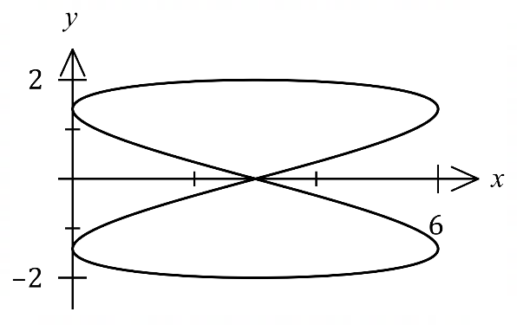The path of a particle with position vector $r(t)$  
is shown in the diagram, where $t$ is the time  
in seconds since motion began and

$r\left(t\right)=\left(\begin{matrix}3-3\sin\left(2t\right) \\ 2\sin{(t)}\end{matrix}\right)$ cm.

(a) State the time at which the particle first touches the $y$-axis. (1 mark)

(b) Determine the Cartesian equation for the path of the particle. (3 marks)

(c) Determine the length of one circuit of the path. (3 marks)

Question 20 (7 marks)

The path of a particle with position vector $r(t)$  
is shown in the diagram, where $t$ is the time  
in seconds since motion began and

$r\left(t\right)=\left(\begin{matrix}3-3\sin\left(2t\right) \\ 2\sin{(t)}\end{matrix}\right)$ cm.

(a) State the time at which the particle first touches the $y$-axis. (1 mark)

|  |
| --- |
| Solution |
| $$3-3\sin\left(2t\right)=0⇒\sin\left(2t\right)=1⇒t=\frac{π}{4} \text{s}$$ |
| Specific behaviours |
| ✓ correct time |

(b) Determine the Cartesian equation for the path of the particle. (3 marks)

|  |
| --- |
| Solution |
| $$y=2\sin\left(t\right)⇒\sin{(t)}=\frac{y}{2}$$ $$x=3-3\sin\left(2t\right) \\ \frac{3-x}{3}=2\sin\left(t\right)\cos\left(t\right) \\ \frac{3-x}{3}=y\cos{(t)}⇒\cos\left(t\right)=\frac{3-x}{3y}$$ $$\sin^{2}{(t)}+\cos^{2}\left(t\right)=1⇒{\left(\frac{y}{2}\right)}^{2}+{\left(\frac{3-x}{3y}\right)}^{2}=1⇒{\left(3-x\right)}^{2}=9y^{2}\left(1-\frac{y^{2}}{4}\right)$$ |
| Specific behaviours |
| ✓ eliminates double angle  ü expressions for $\sin{t}$ and $\cos{t}$ ü uses identity to eliminate $t$ |

(c) Determine the length of one circuit of the path. (3 marks)

|  |
| --- |
| Solution |
| Period is . |
| Specific behaviours |
| ✓ obtains velocity vector  ü writes correct integral for length  ü obtains length with units |

Question 12 (6 marks)

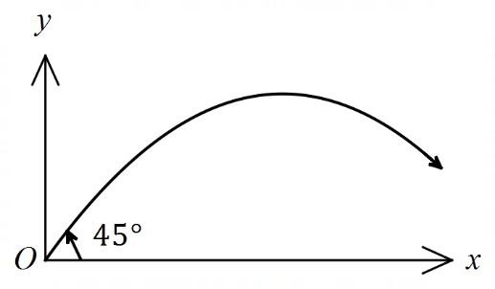A small projectile is launched upwards from $O$  
at an angle of $45°$ to the horizontal,  
with an initial speed of m/s.

The motion of the projectile is only affected  
by gravity, so that the acceleration at any  
time seconds is given by m/s2.

(a) Show that the position vector of the projectile relative to $O$ after $t$ seconds is given by $r\left(t\right)=\left(12\sqrt{2}t\right)i+\left(12\sqrt{2}t-4.9t^{2}\right)j$ 
 m. (3 marks)

(b) Determine the maximum altitude of the projectile above $O$ and the time taken to reach this altitude. (3 marks)

Question 12 (6 marks)

A small projectile is launched upwards from $O$  
at an angle of $45°$ to the horizontal,  
with an initial speed of m/s.

The motion of the projectile is only affected  
by gravity, so that the acceleration at any  
time seconds is given by m/s2.

(a) Show that the position vector of the projectile relative to $O$ after $t$ seconds is given by $r\left(t\right)=\left(12\sqrt{2}t\right)i+\left(12\sqrt{2}t-4.9t^{2}\right)j$ 
 m. (3 marks)

|  |
| --- |
| **Solution** |
| $$r\left(0\right)=0i+0j$$ $$v\left(0\right)=\left(24\cos{45°}\right)i+\left(24\sin{45°}\right)j=\left(12\sqrt{2}\right)i+\left(12\sqrt{2}\right)j$$ $$v\left(t\right)=\int{-9.8j}dt \\ =\left(12\sqrt{2}\right)i+\left(12\sqrt{2}-9.8t\right)j$$ $$r\left(t\right)=\int{v\left(t\right)}dt, r\left(0\right)=0i+0j \\ =\left(12\sqrt{2}t\right)i+\left(12\sqrt{2}t-4.9t^{2}\right)j$$ |
| **Specific behaviours** |
| ✓ antidifferentiates acceleration  ✓ uses $v(0)$ for both constants  ✓ antidifferentiates velocity |

(b) Determine the maximum altitude of the projectile above $O$ and the time taken to reach this altitude. (3 marks)

|  |
| --- |
| **Solution** |
| Maximum altitude when |
| **Specific behaviours** |
| ✓ time to reach maximum  ✓ uses $j$ coefficient of position  ✓ maximum altitude |

Question 15 (8 marks)

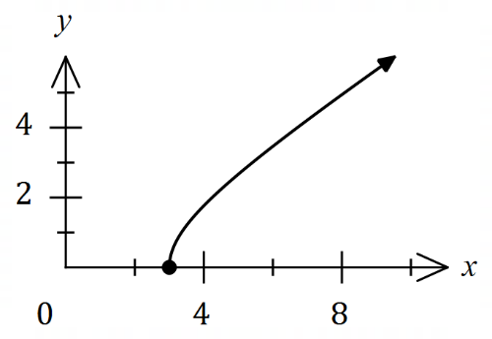The path of a particle is shown in the diagram.  
  
Its position, in metres, relative to the origin $O$  
at time $t$ seconds is given by

$r\left(t\right)=3\sec{(t)}i+2\tan{(t)}j, 0≤t<\frac{π}{2}$.

(a) Determine the Cartesian equation of the path of the particle. (3 marks)

(b) Determine the exact speed of the particle when $t=\frac{π}{3}$. (3 marks)

(c) Determine, correct to two decimal places, the distance the particle travels between $t=0$ and $t=\frac{π}{3}$. (2 marks)

Question 15 (8 marks)

The path of a particle is shown in the diagram.  
  
Its position, in metres, relative to the origin $O$  
at time $t$ seconds is given by

$r\left(t\right)=3\sec{(t)}i+2\tan{(t)}j, 0≤t<\frac{π}{2}$.

(a) Determine the Cartesian equation of the path of the particle. (3 marks)

|  |
| --- |
| **Solution** |
| $$x=3\sec{(t)}, y=2\tan\left(t\right)$$ $$\frac{x^{2}}{9}=\sec^{2}{t}, \frac{y^{2}}{4}=\tan^{2}{t}$$ $$∴\frac{x^{2}}{9}=\frac{y^{2}}{4}+1, \text{where} x≥3 \text{and} y≥0.$$ |
| **Specific behaviours** |
| ✓ indicates use of identity  ✓ correct Cartesian equation (any transposition)  ✓ restricts domain |

(b) Determine the exact speed of the particle when $t=\frac{π}{3}$. (3 marks)

|  |
| --- |
| **Solution** |
| $$v\left(t\right)=\left(3\sin\left(t\right)\sec^{2}{(t)}\right)i+2\left(\sec^{2}{(t)}\right)j$$ $$v\left(\frac{π}{3}\right)=6\sqrt{3}i+8j$$ $$∴\text{speed}=2\sqrt{43} \text{m/s}$$ |
| **Specific behaviours** |
| ✓ derivative of position  ✓ velocity at required time  ✓ exact speed |

(c) Determine, correct to two decimal places, the distance the particle travels between $t=0$ and $t=\frac{π}{3}$. (2 marks)

|  |
| --- |
| **Solution** |
|  |
| **Specific behaviours** |
| ✓ indicates method  ✓ correct distance |

Question 17 (10 marks)

Lines $L_{1}$ and $L_{2}$ have equations $r=\left(\begin{matrix}14 \\ -6 \\ -8\end{matrix}\right)+λ\left(\begin{matrix}4 \\ -1 \\ -3\end{matrix}\right)$ and $r=\left(\begin{matrix}6 \\ -7 \\ -5\end{matrix}\right)+μ\left(\begin{matrix}-2 \\ 2 \\ 3\end{matrix}\right)$ respectively, they both lie in plane $Π$ and they intersect at point $P$.

(a) Determine coordinates of point $P$. (3 marks)

(b) Determine the Cartesian equation of plane $Π$. (4 marks)

Sphere $S$ has a radius of $12$, is tangential to plane $Π$ at point $P$ and the origin lies within it.

(c) Determine the vector equation of sphere $S$. (3 marks)

Question 17 (10 marks)

Lines $L_{1}$ and $L_{2}$ have equations $r=\left(\begin{matrix}14 \\ -6 \\ -8\end{matrix}\right)+λ\left(\begin{matrix}4 \\ -1 \\ -3\end{matrix}\right)$ and $r=\left(\begin{matrix}6 \\ -7 \\ -5\end{matrix}\right)+μ\left(\begin{matrix}-2 \\ 2 \\ 3\end{matrix}\right)$ respectively, they both lie in plane $Π$ and they intersect at point $P$.

(a) Determine coordinates of point $P$. (3 marks)

|  |
| --- |
| **Solution** |
| Equating $i$ and $j$ coefficients: $$14+4λ=6-2μ, -6-λ=-7+2μ$$ Solving simultaneously: $$λ=-3, μ=2$$ No need to check for $k$ coefficients as told lines intersect.  Hence $\vec{OP}=\left(\begin{matrix}6 \\ -7 \\ -5\end{matrix}\right)+2\left(\begin{matrix}-2 \\ 2 \\ 3\end{matrix}\right)=\left(\begin{matrix}2 \\ -3 \\ 1\end{matrix}\right)$ or $P(2, -3, 1)$. |
| **Specific behaviours** |
| ✓ equates coefficients  ✓ solves simultaneously  ✓ coordinates of $P$ |

(b) Determine the Cartesian equation of plane $Π$. (4 marks)

|  |
| --- |
| **Solution** |
| Normal to plane: $$\left(\begin{matrix}4 \\ -1 \\ -3\end{matrix}\right)×\left(\begin{matrix}-2 \\ 2 \\ 3\end{matrix}\right)=\left(\begin{matrix}3 \\ -6 \\ 6\end{matrix}\right)$$ Hence $n=\left(\begin{matrix}1 \\ -2 \\ 2\end{matrix}\right)$ and $k=\left(\begin{matrix}1 \\ -2 \\ 2\end{matrix}\right)∙\left(\begin{matrix}2 \\ -3 \\ 1\end{matrix}\right)=10$ Equation of plane: $\left(\begin{matrix}x \\ y \\ z\end{matrix}\right)∙\left(\begin{matrix}1 \\ -2 \\ 2\end{matrix}\right)=10$. $$x-2y+2z=10$$ |
| **Specific behaviours** |
| ✓ uses directions of lines in cross product  ✓ correct cross product  ✓ indicates use of dot product to obtain constant  ✓ equation in Cartesian form |

Sphere $S$ has a radius of $12$, is tangential to plane $Π$ at point $P$ and the origin lies within it.

(c) Determine the vector equation of sphere $S$. (3 marks)

|  |
| --- |
| **Solution** |
| Centre of sphere: $$\vec{OC}=\vec{OP}±12\hat{n}$$ $${\vec{OC}}_{1}=\left(\begin{matrix}2 \\ -3 \\ 1\end{matrix}\right)+\frac{12}{3}×\left(\begin{matrix}1 \\ -2 \\ 2\end{matrix}\right)=\left(\begin{matrix}6 \\ -11 \\ 9\end{matrix}\right)$$ $${\vec{OC}}_{2}=\left(\begin{matrix}2 \\ -3 \\ 1\end{matrix}\right)-\frac{12}{3}×\left(\begin{matrix}1 \\ -2 \\ 2\end{matrix}\right)=\left(\begin{matrix}-2 \\ 5 \\ -7\end{matrix}\right)$$ For sphere to contain $O$ require :  Equation of : |
| **Specific behaviours** |
| ✓ indicates method to locate both centres  ✓ indicates method to check contains origin  ✓ correct equation  *(NB Max 1/3 if no check for origin seen)* |

Question 19 (12 marks)

Points $A$, $B$ and $C$ lie in plane $Π$ and have position vectors $\left(\begin{matrix}-2 \\ 0 \\ 9\end{matrix}\right),\left(\begin{matrix}3 \\ -1 \\ 1\end{matrix}\right)$ and $\left(\begin{matrix}2 \\ 2 \\ 4\end{matrix}\right)$ respectively.

Point $B$ also lies on the sphere $S$ that has centre $A$.

(a) Determine the vector equation of $S$. (3 marks)

(b) Determine the Cartesian equation for plane $Π$. (4 marks)

A point and its reflection in a plane are equidistant from the plane and lie on a line that is perpendicular to the plane.

Point $P$ has position vector $\left(\begin{matrix}9 \\ -9 \\ 16\end{matrix}\right)$.

(c) Determine the position vector of $P'$, the reflection of $P$ in plane $Π$. (5 marks)

Question 19 (12 marks)

Points $A$, $B$ and $C$ lie in plane $Π$ and have position vectors $\left(\begin{matrix}-2 \\ 0 \\ 9\end{matrix}\right),\left(\begin{matrix}3 \\ -1 \\ 1\end{matrix}\right)$ and $\left(\begin{matrix}2 \\ 2 \\ 4\end{matrix}\right)$ respectively.

Point $B$ also lies on the sphere $S$ that has centre $A$.

(a) Determine the vector equation of $S$. (3 marks)

|  |
| --- |
| **Solution** |
|  |
| **Specific behaviours** |
| ✓ vector $\vec{AB}$ ✓ calculates radius  ✓ states vector equation |

(b) Determine the Cartesian equation for plane $Π$. (4 marks)

|  |
| --- |
| **Solution** |
| $$\vec{AC}=\left(\begin{matrix}2 \\ 2 \\ 4\end{matrix}\right)-\left(\begin{matrix}-2 \\ 0 \\ 9\end{matrix}\right)=\left(\begin{matrix}4 \\ 2 \\ -5\end{matrix}\right)$$ $$\vec{AB}×\vec{AC}=\left(\begin{matrix}21 \\ -7 \\ 14\end{matrix}\right) \\ n=\left(\begin{matrix}3 \\ -1 \\ 2\end{matrix}\right)$$ $$\vec{OA}∙n=\left(\begin{matrix}-2 \\ 0 \\ 9\end{matrix}\right)∙\left(\begin{matrix}3 \\ -1 \\ 2\end{matrix}\right)=12$$ $$3x-y+2z=12$$ |
| **Specific behaviours** |
| ✓ vector $\vec{AC}$ or $\vec{BC}$, etc  ✓ uses cross product to obtain normal  ✓ uses dot product to obtain constant  ✓ states Cartesian form |

A point and its reflection in a plane are equidistant from the plane and lie on a line that is perpendicular to the plane.

Point $P$ has position vector $\left(\begin{matrix}9 \\ -9 \\ 16\end{matrix}\right)$.

(c) Determine the position vector of $P'$, the reflection of $P$ in plane $Π$. (5 marks)

|  |
| --- |
| **Solution** |
| Line through $P$ perpendicular to plane: $$r=\left(\begin{matrix}9 \\ -9 \\ 16\end{matrix}\right)+λ\left(\begin{matrix}3 \\ -1 \\ 2\end{matrix}\right)$$ Line intersects plane at $Q$, when: $$\left[\left(\begin{matrix}9 \\ -9 \\ 16\end{matrix}\right)+λ\left(\begin{matrix}3 \\ -1 \\ 2\end{matrix}\right)\right]∙\left(\begin{matrix}3 \\ -1 \\ 2\end{matrix}\right)=12$$ $$3\left(9+3λ\right)-\left(-9-λ\right)+2\left(16+2λ\right)=12 \\ λ=-4$$ Hence $\vec{OQ}=r(-4)$ and so $\vec{OP^{'}}=r(-8)$: $$\vec{OP^{'}}=\left(\begin{matrix}9 \\ -9 \\ 16\end{matrix}\right)-8\left(\begin{matrix}3 \\ -1 \\ 2\end{matrix}\right) \\ =\left(\begin{matrix}-15 \\ -1 \\ 0\end{matrix}\right)$$ |
| **Specific behaviours** |
| ✓ writes equation of line through $P$ ✓ substitutes line into plane  ✓ solves for $λ$ ✓ indicates method to determine $P'$ ✓ correct position vector for $P'$ |

Question 21 (11 marks)

The path of a particle is shown in the diagram below.

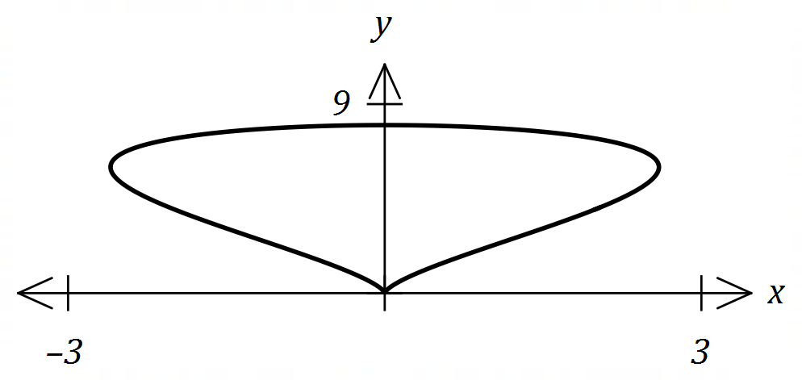

The position vector of the particle after $t$ seconds is given by $r\left(t\right)=\left(\begin{matrix}2cos{t}+\sin{2t} \\ 4+4\sin{t}\end{matrix}\right)$ centimetres, for $t≥0$.

(a) Determine the initial position of the particle. (1 mark)

(b) Determine the acceleration vector of the particle at the instant it first reaches the origin.

(3 marks)

(c) Determine the distance travelled by the particle from the time it leaves its initial position until the time it first reaches the origin. (3 marks)

(d) The Cartesian equation of the path of the particle is $ax^{2}+by^{3}+y^{4}=0$. Determine the value of each of the constants $a$ and $b$. (4 marks)

Question 21 (11 marks)

The path of a particle is shown in the diagram below.



The position vector of the particle after $t$ seconds is given by $r\left(t\right)=\left(\begin{matrix}2cos{t}+\sin{2t} \\ 4+4\sin{t}\end{matrix}\right)$ centimetres, for $t≥0$.

(a) Determine the initial position of the particle. (1 mark)

|  |
| --- |
| **Solution** |
| $$r\left(0\right)=\left(\begin{matrix}2 \\ 4\end{matrix}\right) \text{cm}$$ |
| **Specific behaviours** |
| ✓ correct position |

(b) Determine the acceleration vector of the particle at the instant it first reaches the origin.

(3 marks)

|  |
| --- |
| **Solution** |
| $$y=0⇒4+4\sin{t}=0⇒t=\frac{3π}{2}$$ $$v\left(t\right)=\left(\begin{matrix}-2\sin{t}+2cos{2t} \\ 4\cos{t}\end{matrix}\right)$$ $$a\left(t\right)=\left(\begin{matrix}-2cos{t}-4\sin{2t} \\ -4\sin{t}\end{matrix}\right)$$ $$a\left(\frac{3π}{2}\right)=\left(\begin{matrix}0 \\ 4\end{matrix}\right) \text{cm }{\text{s}}^{-2}$$ |
| **Specific behaviours** |
| ✓ indicates time  ✓ differentiates twice  ✓ substitutes and simplifies |

(c) Determine the distance travelled by the particle from the time it leaves its initial position until the time it first reaches the origin. (3 marks)

|  |
| --- |
| **Solution** |
|  |
| **Specific behaviours** |
| ✓ expression for magnitude of velocity  ✓ forms correct integral  ✓ correct distance |

(d) The Cartesian equation of the path of the particle is $ax^{2}+by^{3}+y^{4}=0$. Determine the value of each of the constants $a$ and $b$. (4 marks)

|  |
| --- |
| **Solution** |
| $$x=2\cos{t}+2\cos{t}\sin{t} \\ =2\cos{t}\left(1+\sin{t}\right)$$ $$y=4+4\sin{t}⇒\frac{y}{4}=1+\sin{t}$$ $$x=2\cos{t}\left(\frac{y}{4}\right) \\ 2x=y\cos{t}$$ $$4x^{2}=y^{2}\cos^{2}{t} \\ =y^{2}(1-\sin^{2}{t})$$ $$\sin{t}=\frac{y}{4}-1⇒\sin^{2}{t}={\left(\frac{y}{4}-1\right)}^{2}=\frac{y^{2}}{16}-\frac{y}{2}+1$$ $${4x}^{2}=y^{2}\left(1-\frac{y^{2}}{16}+\frac{y}{2}-1\right) \\ 4x^{2}=\frac{y^{3}}{2}-\frac{y^{4}}{16} \\ 64x^{2}=8y^{3}-y^{4}⇒a=64, b=-8$$ |
| **Specific behaviours** |
| ✓ obtains relation between $x$, $y$ and $\cos{t}$ ✓ obtains relation for $\sin^{2}{t}$ in terms of $y$ ✓ eliminates all trig terms  ✓ correct values for constants |

Question 9 (4 marks)

A sphere has diameter $AB$ where points $A$ and $B$ have position vectors $(0, -4, 6)$ and $(4, -2, 0)$ respectively.

(a) Determine the vector equation of the sphere. (2 marks)

(b) State, with justification, whether the point $P$ with position vector $(3, -3, 6)$ lies inside, outside or on the surface of the sphere. (2 marks)

Question 9 (4 marks)

A sphere has diameter $AB$ where points $A$ and $B$ have position vectors $(0, -4, 6)$ and $(4, -2, 0)$ respectively.

(a) Determine the vector equation of the sphere. (2 marks)

|  |
| --- |
| **Solution** |
|  |
| **Specific behaviours** |
| ✓ determines radius  ✓ correct centre and vector equation |

(b) State, with justification, whether the point $P$ with position vector $(3, -3, 6)$ lies inside, outside or on the surface of the sphere. (2 marks)

|  |
| --- |
| **Solution** |
|  |
| **Specific behaviours** |
| ✓ determines distance from centre  ✓ correct conclusion |

Question 13 (7 marks)

The position vector $r$ at time $t$ seconds of a small particle $P$ is shown below and given by

$$r\left(t\right)=\left(5\cos\left(t\right)-4\cos\left(3t\right)\right)i+(5\sin\left(t\right)-4\sin\left(3t\right))j \text{cm}.$$

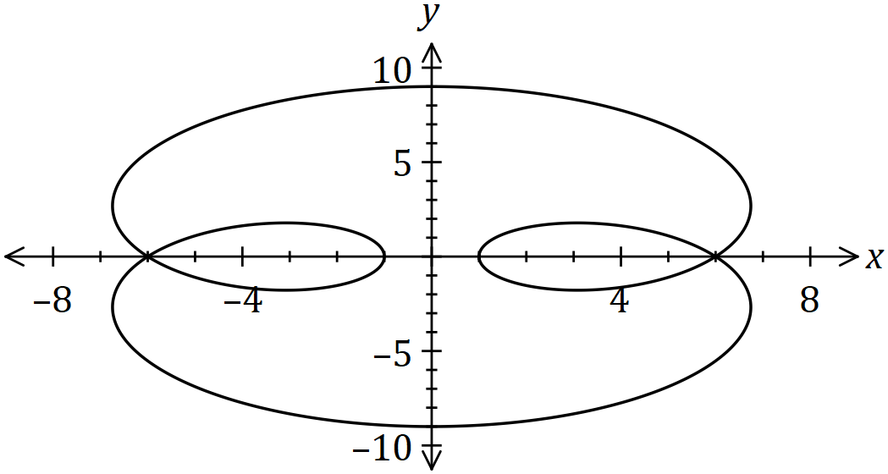

(a) Determine the change in displacement of $P$ between $t=0$ and $t=\frac{π}{2}$. (2 marks)

(b) Determine the velocity vector of $P$ when $t=\frac{π}{2}$. (2 marks)

(c) Determine the total distance travelled by $P$ until it first returns to its initial position.

(3 marks)

Question 13 (7 marks)

The position vector $r$ at time $t$ seconds of a small particle $P$ is shown below and given by



$$r\left(t\right)=\left(5\cos\left(t\right)-4\cos\left(3t\right)\right)i+(5\sin\left(t\right)-4\sin\left(3t\right))j \text{cm}.$$

(a) Determine the change in displacement of $P$ between $t=0$ and $t=\frac{π}{2}$. (2 marks)

|  |
| --- |
| **Solution** |
| $$r\left(0\right)=i, r\left(\frac{π}{2}\right)=9j, ∆r=-i+9j \text{cm}$$ |
| **Specific behaviours** |
| ✓ determines positions  ✓ states change |

(b) Determine the velocity vector of $P$ when $t=\frac{π}{2}$. (2 marks)

|  |
| --- |
| **Solution** |
| $$v\left(t\right)=(-5\sin\left(t\right)+12\sin\left(3t\right))i+\left(5\cos\left(t\right)-12\cos{(3t)}\right)j \\ v\left(\frac{π}{2}\right)=-17i \text{cm/s}$$ |
| **Specific behaviours** |
| ✓ differentiates to obtain velocity vector  ✓ states velocity vector |

(c) Determine the total distance travelled by $P$ until it first returns to its initial position.

(3 marks)

|  |
| --- |
| **Solution** |
|  |
| **Specific behaviours** |
| ✓ determines time to return  ✓ correct integral  ✓ distance (that rounds to 79 cm). |

Question 18 (11 marks)

Small bodies $P$ and $Q$ are initially at $A(3, -1, -4)$ and $C(5, 5, -6)$ respectively and are travelling with constant velocities.

One second later, $P$ and $Q$ are at $B(2, -2, -1)$ and $D(4, 3, -4)$ respectively.

(a) Determine the vector equation for the path of $P$ at any time $t$, where $t=0$ when $P$ is at $A$.

(2 marks)

(b) Show that the paths of $P$ and $Q$ cross, stating the point of intersection and explaining whether they also collide. (6 marks)

(c) A third small body $G$ is stationary at the point $(7, 12, -8)$. Determine whether $G$ lies in the same plane as the paths of $P$ and $Q$. (3 marks)

Question 18 (11 marks)

Small bodies $P$ and $Q$ are initially at $A(3, -1, -4)$ and $C(5, 5, -6)$ respectively and are travelling with constant velocities.

One second later, $P$ and $Q$ are at $B(2, -2, -1)$ and $D(4, 3, -4)$ respectively.

(a) Determine the vector equation for the path of $P$ at any time $t$, where $t=0$ when $P$ is at $A$.

(2 marks)

|  |
| --- |
| **Solution** |
| $$\vec{AB}=\left(2, -2, -1\right)-\left(3, -1, -4\right)=\left(-1, -1, 3\right)$$ $$r_{P}=\left(3, -1, -4\right)+t\left(-1, -1, 3\right)$$ |
| **Specific behaviours** |
| ✓ direction vector  ✓ correct equation |

(b) Show that the paths of $P$ and $Q$ cross, stating the point of intersection and explaining whether they also collide. (6 marks)

|  |
| --- |
| **Solution** |
| $$\vec{CD}=\left(4, 3, -4\right)-\left(5, 5, -6\right)=\left(-1, -2, 2\right)$$ $$r_{Q}=\left(5, 5, -6\right)+s\left(-1, -2, 2\right)$$ $$i \text{coeffs}:3-t=5-s$$ $$j \text{coeffs}: -1-t=5-2s$$ $$∴t=2, s=4$$ $$r_{P}\left(2\right)=\left(3, -1, -4\right)+2\left(-1, -1, 3\right)=(1, -3, 2)$$ $$r_{Q}\left(4\right)=\left(5, 5, -6\right)+4\left(-1, -2, 2\right)=(1, -3, 2)$$ Since $k$ coefficients are both $2$, then paths cross.  However, $P$ and $Q$ do not meet as they are at intersection at different times. |
| **Specific behaviours** |
| ✓ equation for path of $Q$ ✓ equates $i$ and $j$ coefficients  ✓ solves for times  ✓ checks $k$ coefficents for consistency  ✓ states point of intersection  ✓ states that paths cross, explains don't meet |

(c) A third small body $G$ is stationary at the point $(7, 12, -8)$. Determine whether $G$ lies in the same plane as the paths of $P$ and $Q$. (3 marks)

|  |
| --- |
| **Solution** |
| $$n=\left(\begin{matrix}-1 \\ -1 \\ 3\end{matrix}\right)×\left(\begin{matrix}-1 \\ -2 \\ 2\end{matrix}\right)=\left(\begin{matrix}4 \\ -1 \\ 1\end{matrix}\right)$$ $$r∙n=\left(\begin{matrix}1 \\ -3 \\ 2\end{matrix}\right)∙\left(\begin{matrix}4 \\ -1 \\ 1\end{matrix}\right)=9$$ $$\left(\begin{matrix}7 \\ 12 \\ -8\end{matrix}\right)∙\left(\begin{matrix}4 \\ -1 \\ 1\end{matrix}\right)=28-12-8=8⇒\text{Not in same plane}$$ |
| **Specific behaviours** |
| ✓ determines normal to plane  ✓ determines equation of plane  ✓ substitutes point and draws conclusion |

Question 10 (6 marks)

Three planes have the following equations, where $a$ and $b$ are constants.

$$2y+z=-5 \\ 5x+y-2z=5 \\ 5x+3y+az=b$$

(a) Determine the coordinates of the point of intersection of the three planes when $a=-2$ and $b=7$. (2 marks)

(b) Determine any restrictions on the constants $a$ and $b$ if the planes

(i) intersect in a straight line. (3 marks)

(ii) neither intersect at a point nor in a straight line. (1 mark)

Question 10 (6 marks)

Three planes have the following equations, where $a$ and $b$ are constants.

$$2y+z=-5 \\ 5x+y-2z=5 \\ 5x+3y+az=b$$

(a) Determine the coordinates of the point of intersection of the three planes when $a=-2$ and $b=7$. (2 marks)

|  |
| --- |
| **Solution** |
| $$\text{R3-R2}:2y=2⇒y=1, z=-7, x=-2$$ $$\text{At} (-2, 1, -7)$$ |
| **Specific behaviours** |
| ✓ indicates elimination of variables  ✓ point of intersection (may use CAS) |

(b) Determine any restrictions on the constants $a$ and $b$ if the planes

(i) intersect in a straight line. (3 marks)

|  |
| --- |
| **Solution** |
| $$\text{R3-R2-R1}:\left(a+1\right)z=b$$ $$\text{Require} a+1=0 \text{and} b=0$$ $$a=-1, b=0$$ |
| **Specific behaviours** |
| ✓ eliminates two variables  ✓ indicates coefficient of $z$ and constant must both be zero  ✓ states restrictions |

(ii) neither intersect at a point nor in a straight line. (1 mark)

|  |
| --- |
| **Solution** |
| $$a=-1, b≠0$$ |
| **Specific behaviours** |
| ✓ states restrictions |

Question 13 (8 marks)

The position of particle $P$ at any time $s$ seconds is given by $r=3i-7j+s(2i+3j-2k)$, where distances are in metres.

(a) Show that when $s=3$, $P$ is $11$ m from the origin. (2 marks)

When $s=0$, particle $Q$ leaves the point $(5, -8, -14)$ and moves with constant velocity, passing through the point $(11, 4, -11)$ three seconds later.

(b) Describe the path of $Q$ as a vector function of time $t$ seconds. (2 marks)

(c) Determine where the paths of $P$ and $Q$ cross, and explain whether the particles meet.

(4 marks)

Question 13 (8 marks)

The position of particle $P$ at any time $s$ seconds is given by $r=3i-7j+s(2i+3j-2k)$, where distances are in metres.

(a) Show that when $s=3$, $P$ is $11$ m from the origin. (2 marks)

|  |
| --- |
| **Solution** |
| $$r\left(3\right)=\left(9, 2, -6\right)$$ $$\sqrt{9^{2}+2+{\left(-6\right)}^{2}}=\sqrt{121}=11$$ |
| **Specific behaviours** |
| ✓ indicates position of  ✓ shows magnitude calculation |

When $s=0$, particle $Q$ leaves the point $(5, -8, -14)$ and moves with constant velocity, passing through the point $(11, 4, -11)$ three seconds later.

(b) Describe the path of $Q$ as a vector function of time $t$ seconds. (2 marks)

|  |
| --- |
| **Solution** |
| $$\frac{1}{3}\left[\left(11, 4, -11\right)-\left(5, -8, -14\right)\right]=(2, 4, 1)$$ $$r=5i-8j-14k+t(2i+4j+k)$$ |
| **Specific behaviours** |
| ✓ indicates direction vector  ✓ states equation of path |

(c) Determine where the paths of $P$ and $Q$ cross, and explain whether the particles meet.

(4 marks)

|  |
| --- |
| **Solution** |
| $$3+2s=5+2t \\ -7+3s=-8+4t \\ 2s=-14+t$$ $$\text{Soln}:s=5, t=4$$ $$\text{Paths intersect at} (13, 8, -10)$$ $$\text{Particles do not meet as paths cross at different times}$$ |
| **Specific behaviours** |
| ✓ indicates equations to solve  ✓ solves equations  ✓ determines point  ✓ states no meeting, with reason |

Question 18 (9 marks)

The position vector of a particle at time $t$ seconds, $t≥0$, is shown below, with distances in cm.

$$r\left(t\right)=\left(\begin{matrix}4\cos{t}-1 \\ 3\sin{t}-1\end{matrix}\right)$$

(a) Determine the speed of the particle when $t=\frac{2π}{3}$. (3 marks)

(b) Express the path of the particle as a Cartesian equation. (2 marks)

(c) Sketch the path of the particle on the axes below, indicating its position and the direction it is moving when $t=\frac{2π}{3}$. (4 marks)

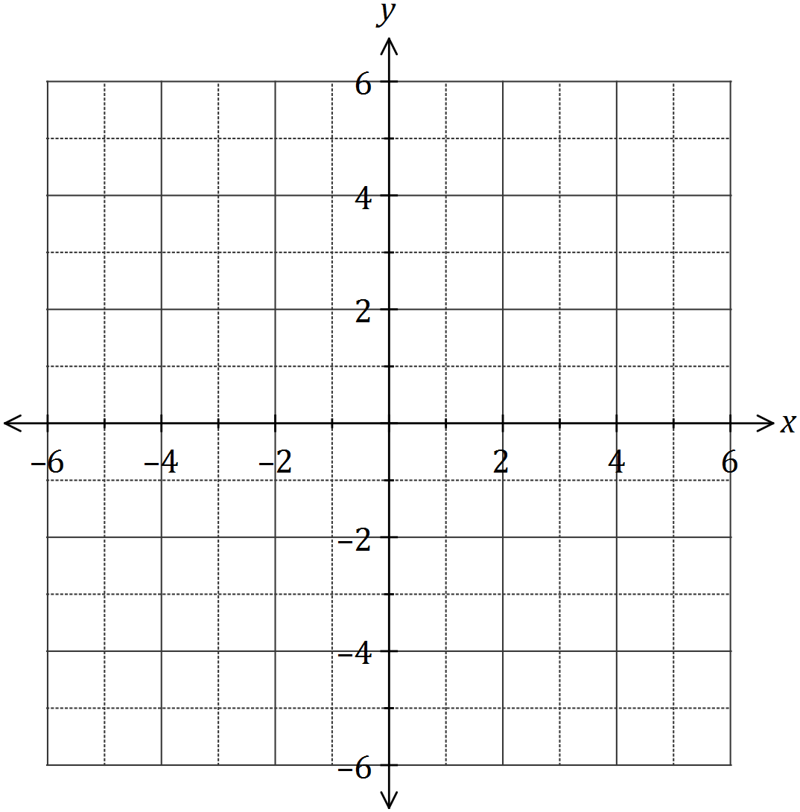

Question 18 (9 marks)

The position vector of a particle at time $t$ seconds, $t≥0$, is shown below, with distances in cm.

$$r\left(t\right)=\left(\begin{matrix}4\cos{t}-1 \\ 3\sin{t}-1\end{matrix}\right)$$

(a) Determine the speed of the particle when $t=\frac{2π}{3}$. (3 marks)

|  |
| --- |
| **Solution** |
| $$v\left(t\right)=\left(\begin{matrix}-4\sin{t} \\ 3\cos{t}\end{matrix}\right), v\left(\frac{2π}{3}\right)=\left(\begin{matrix}-2\sqrt{3} \\ -1.5\end{matrix}\right), \text{speed}=\frac{\sqrt{57}}{2}≈3.77 \text{cm/s}$$ |
| **Specific behaviours** |
| ✓ differentiates to obtain velocity vector  ✓ substitutes time to obtain velocity  ✓ determines magnitude of velocity |

(b) Express the path of the particle as a Cartesian equation. (2 marks)

|  |
| --- |
| **Solution** |
| $$\cos{t}=\frac{x+1}{4}, \sin{t}=\frac{y+1}{3}$$ $${\left(\frac{x+1}{4}\right)}^{2}+{\left(\frac{y+1}{3}\right)}^{2}=1$$ |
| **Specific behaviours** |
| ✓ rearranges for $\sin{t}$ and  ✓ eliminates $t$ to obtain Cartesian equation |

(c) Sketch the path of the particle on the axes below, indicating its position and the direction it is moving when $t=\frac{2π}{3}$ (4 marks)

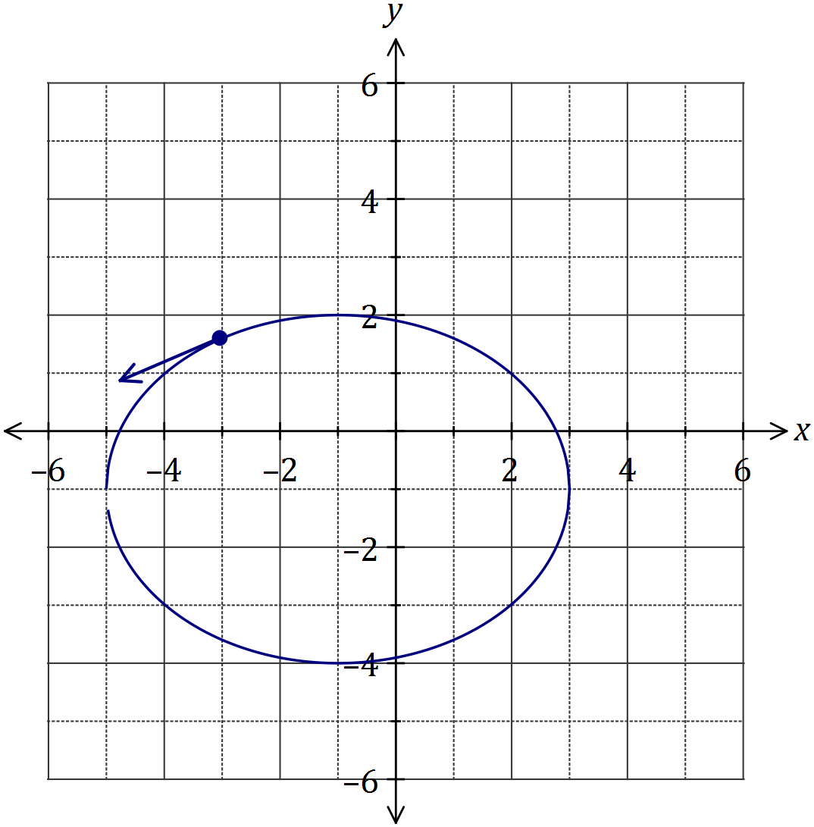

|  |
| --- |
| **Solution** |
| See graph |
| **Specific behaviours** |
| ✓ ellipse, correct centre  ✓ ellipse, correct shape  ✓ position  ✓ direction $(\text{slope}≈\frac{1}{2})$ |